Python Data Structures
Lists
- Creation
- Indexing
- Slicing
- Methods
Tuples
- Immutable collections
- Operations
Sets
- Unique values
- Set operations
Dictionaries
- Key-value pairs
- CRUD operations
Nested Structures
Hands-on Labs
▸ Student record management
▸ Inventory tracker
Assignment
- Contact management system

Functions and Modules
Functions
- Definition
- Parameters
- Return values
Types of Arguments
- Positional
- Keyword
- Default
- Variable-length
Lambda Functions
Scope
- Local
- Global
Modules
- Importing modules
- Creating custom modules

Important Built-in Modules
- math
- random
- datetime
Hands-on Labs
▸ Calculator using functions
▸ Random password generator

Python Data Structures
A data structure is a way of organizing & storing data so that it can be accessed, processed & managed efficiently.
Fundamental Data Structures in Python
- Lists – A list is an ordered, mutable collection of elements.
List operations
  - Add elements
  - Remove elements
  - Update elements
  - Search elements
  - Sort elements
  - Reverse elements
  - Count elements
  - Find length of list
  - Copy lists
  - Slice extraction
Common list methods
  - append()
  - extend()
  - insert()
  - remove()
  - pop()
  - clear()
  - sort()
  - reverse()
  - count()
  - index()
  - copy()
- Tuples – A tuple is an ordered, immutable collection.
Tuple packing: Python allows multiple values to be grouped together into tuple.
Value1 + value2 + values3 -> Tuple
Tuple unpacking: Reverse process of tuple packing.
Tuple

Value1 -> variable A
Value2 -> variable B
Value3 -> variable C
- Sets
Set operations
  - Union -> A U B
  - Intersection -> A ∩ B
  - Difference -> A-B
- Dictionaries – A dictionary stores data in key-value pairs.
Dictionary operations
  - Add a Key-Value pair
  - Update a value using key
  - Removing a key-value pair
  - Search a key
  - Get a value
  - Get all keys
  - Get all values
  - Get all key-value pairs
  - Check whether a key exists
Common dictionary methods
- get()
- keys()
- values()
- items()
- update()
- pop()
- popitem()
- clear()
- setdefault()
Classification of Python Data Structures
Data Structure | Ordered | Mutable | Allows Duplicates | Access Method
List | Yes | Yes | Yes | Index
Tuple | Yes | No | Yes | Index
Set | No guaranteed positional order | Yes | No | Membership
Dictionary | Yes | Yes | Keys must be unique | Key

Decision Guide
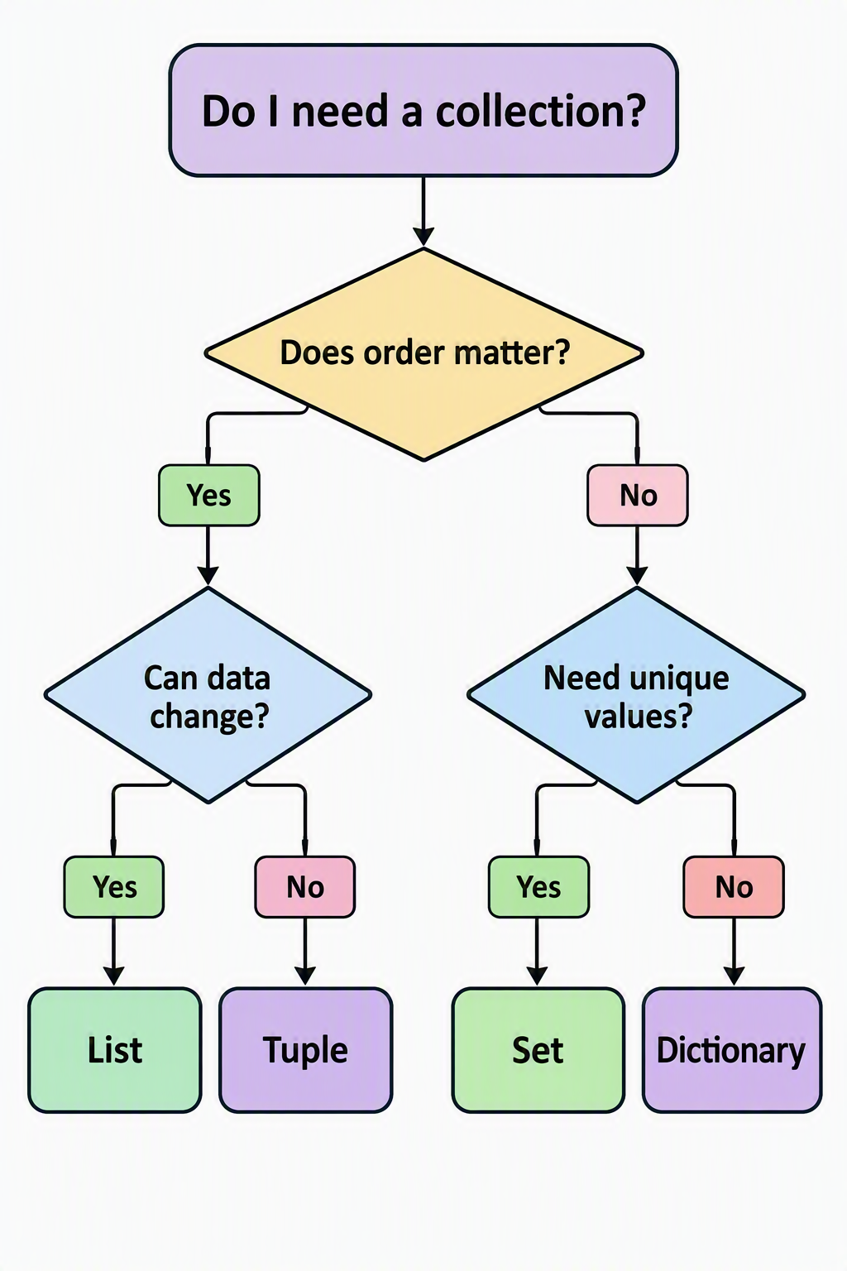
Hands-on Labs
1. Lab Title
Student Record Management System
2. Objective
Develop a console-based Python application for managing student records.
The application should allow the user to create, view, search, update, and delete student records. It should also calculate student results based on subject marks.
The lab is intended to provide practical experience with:
- Variables and data types
- Lists
- Dictionaries
- Nested dictionaries
- Conditional statements
- for and while loops
- Functions
- CRUD operations
- Searching and filtering
- Arithmetic operations
- User input and output
3. Business Scenario
A training institute wants to maintain student information using a Python-based application.
The system should maintain information such as student ID, name, age, course, and marks obtained in different subjects.
The application should provide a menu-driven interface through which an administrator can manage student records.
4. Functional Requirements
FR-01: Add Student
The system shall allow the user to add a new student.
The following information shall be captured:
- Student ID
- Student Name
- Age
- Course
- Python Marks
- SQL Marks
- Azure Marks
The system shall store the student information in an appropriate Python data structure.
FR-02: View Students
The system shall display all student records.
For each student, the system shall display:
- Student ID
- Name
- Age
- Course
- Subject-wise marks
If no students exist, the system shall display an appropriate message.
FR-03: Search Student
The system shall allow the user to search for a student using the Student ID.
If the student exists, all available information shall be displayed.
If the student does not exist, the system shall display an appropriate message.
FR-04: Update Student
The system shall allow the user to update an existing student's information.
The user should be able to update:
- Name
- Age
- Course
The system shall identify the student using Student ID.
FR-05: Delete Student
The system shall allow the user to delete a student record using Student ID.
The system shall display a confirmation message after successful deletion.
FR-06: Calculate Student Result
The system shall calculate:
- Total marks
- Average marks
- Pass/Fail status
The pass criterion shall be an average score of 40 or above.
FR-07: Identify Highest Scorer
The system shall identify the student having the highest average marks.
The system shall display:
- Student ID
- Student Name
- Average Marks
FR-08: Menu
The application shall provide a menu similar to:
- Add Student
- View Students
- Search Student
- Update Student
- Delete Student
- Calculate Result
- Display Highest Scorer
- Exit
5. Technical Requirements
The implementation shall:
- Use Python.
- Use a list to maintain multiple students.
- Use dictionaries to represent individual students.
- Use a nested dictionary for subject marks.
- Use functions to implement individual operations.
- Use loops for processing multiple records.
- Use conditional statements for decision-making.
- Use appropriate Python built-in functions wherever applicable.
6. Validation Requirements
The application should validate:
- Student ID should not be empty.
- Age should be numeric.
- Marks should be numeric.
- Marks should be within an appropriate range such as 0–100.
- Student ID should preferably be unique.
7. Expected Outcome
At the completion of the lab, the learner should be able to develop a functional console-based student record management application using Python collections and control structures.
8. Acceptance Criteria
The lab shall be considered complete when:
- A student can be added successfully.
- Multiple students can be stored.
- Student records can be displayed.
- A student can be searched using Student ID.
- Existing student information can be updated.
- Student records can be deleted.
- Student results can be calculated.
- The highest-scoring student can be identified.
- Invalid menu selections are handled appropriately.
- The application continues running until the user selects Exit.

Hands-on Lab 2: Inventory Tracker
1. Lab Title
Inventory Tracker
2. Objective
Develop a console-based Python application for managing product inventory.
The application should allow users to add products, view inventory, search products, modify stock information, sell products, calculate inventory value, and identify low-stock products.
3. Business Scenario
A small retail organization wants to maintain its inventory using a Python application.
Each product should contain information such as product ID, product name, category, price, and available quantity.
The system should allow an inventory administrator to manage stock through a menu-driven interface.
4. Functional Requirements
FR-01: Add Product
The system shall allow the user to add a product.
The following information shall be captured:
- Product ID
- Product Name
- Category
- Price
- Quantity
The Product ID should uniquely identify a product.
FR-02: View Inventory
The system shall display all products currently available in the inventory.
For each product, the system shall display:
- Product ID
- Product Name
- Category
- Price
- Quantity
If no products exist, an appropriate message shall be displayed.
FR-03: Search Product
The system shall allow the user to search for a product using Product ID.
If the product exists, its complete information shall be displayed.
If the product does not exist, an appropriate message shall be displayed.
FR-04: Update Product
The system shall allow the user to modify product information.
The following fields should be updateable:
- Price
- Quantity
- Category
The product shall be identified using Product ID.
FR-05: Delete Product
The system shall allow the user to delete a product using Product ID.
The system shall display a confirmation message after successful deletion.
FR-06: Sell Product
The system shall allow the user to sell a specified quantity of a product.
The system shall:
- Accept Product ID.
- Accept quantity to sell.
- Check available stock.
- Reduce inventory quantity if sufficient stock exists.
- Calculate the total sale amount.
The system shall not allow the quantity sold to exceed available inventory.
FR-07: Calculate Inventory Value
The system shall calculate the total value of inventory.
The calculation shall be:
Inventory Value = Product Price × Available Quantity
The system shall calculate the value for every product and display the overall inventory value.
FR-08: Identify Low Stock
The system shall identify products whose available quantity is below a predefined threshold.
The default low-stock threshold shall be 10 units.
The system shall display:
- Product Name
- Available Quantity
FR-09: Menu
The application shall provide a menu similar to:
- Add Product
- View Inventory
- Search Product
- Update Product
- Delete Product
- Sell Product
- Calculate Inventory Value
- Display Low Stock Products
- Exit
5. Technical Requirements
The implementation shall:
- Use Python.
- Use a list to maintain multiple products.
- Use dictionaries to represent individual products.
- Use functions for individual operations.
- Use loops to process inventory records.
- Use conditional statements for business rules.
- Use arithmetic operations for inventory calculations.
6. Validation Requirements
The application should validate:
- Product ID should not be empty.
- Product ID should be unique.
- Price should be numeric.
- Price should not be negative.
- Quantity should be an integer.
- Quantity should not be negative.
- Sale quantity should not exceed available stock.
- Invalid menu choices should be handled appropriately.
7. Expected Outcome
At the completion of the lab, the learner should be able to build a functional inventory management application using Python collections, functions, loops, conditions, and arithmetic operations.
8. Acceptance Criteria
The lab shall be considered complete when:
- Products can be added.
- Multiple products can be maintained.
- Inventory can be displayed.
- Products can be searched.
- Product information can be updated.
- Products can be deleted.
- Product sales can be processed.
- Stock quantities are updated after sales.
- Insufficient-stock situations are handled.
- Total inventory value can be calculated.
- Low-stock products can be identified.
- The application remains operational until Exit is selected.

Hands-on Lab 3: Contact Management System
1. Lab Title
Contact Management System
2. Objective
Develop a console-based Python application for maintaining personal and business contacts.
The application should allow users to create, view, search, update, and delete contacts. It should also support searching contacts by city and category.
The lab should demonstrate the practical use of:
- Lists
- Dictionaries
- Sets
- Functions
- Loops
- Conditional statements
- CRUD operations
- String operations
- Searching and filtering
3. Business Scenario
An organization wants a simple Python-based contact management application.
The system should maintain contact information including name, phone number, email address, city, and contact category.
The application should prevent duplicate phone numbers.
4. Functional Requirements
FR-01: Add Contact
The system shall allow the user to create a new contact.
The following information shall be captured:
- Contact ID
- Name
- Phone Number
- Email Address
- City
- Category
Possible categories may include:
- Friend
- Family
- Business
- Customer
- Vendor
- Other
FR-02: Prevent Duplicate Phone Numbers
The system shall prevent multiple contacts from being registered with the same phone number.
The application should use an appropriate Python data structure, such as a set, to track existing phone numbers.
If a duplicate number is entered, the system shall display an appropriate message and shall not create the contact.
FR-03: View Contacts
The system shall display all stored contacts.
For each contact, the following information shall be displayed:
- Contact ID
- Name
- Phone Number
- Email
- City
- Category
FR-04: Search Contact
The system shall allow users to search for contacts by name.
The search should preferably be case-insensitive.
For example, searching for:
rahul
should also find:
Rahul Sharma
FR-05: Update Contact
The system shall allow users to modify an existing contact.
The following information should be updateable:
- Name
- Phone Number
- Email
- City
- Category
The contact shall be identified using Contact ID.
If the phone number is changed, the system shall ensure that the new phone number is not already associated with another contact.
FR-06: Delete Contact
The system shall allow users to delete a contact using Contact ID.
When a contact is deleted, its phone number should also be removed from the collection used to track unique phone numbers.
FR-07: Search by City
The system shall allow users to search for contacts belonging to a specific city.
For example:
Vadodara
should display all contacts whose city is Vadodara.
FR-08: Search by Category
The system shall allow users to search for contacts belonging to a particular category.
For example:
Business
should display all business contacts.
FR-09: Contact Count
The system shall display the total number of contacts currently stored.
FR-10: Menu
The application shall provide a menu similar to:
- Add Contact
- View Contacts
- Search Contact
- Update Contact
- Delete Contact
- Search by City
- Search by Category
- Display Contact Count
- Exit
5. Technical Requirements
The implementation shall:
- Use Python.
- Use a list to maintain contact records.
- Use dictionaries to represent individual contacts.
- Use a set to maintain unique phone numbers.
- Use functions for individual operations.
- Use loops to process contact records.
- Use conditional statements for decision-making.
- Use string methods for case-insensitive searching.
6. Validation Requirements
The application should validate:
- Contact ID should not be empty.
- Contact ID should preferably be unique.
- Name should not be empty.
- Phone number should not be empty.
- Phone number should be unique.
- Email should follow a reasonable format.
- Invalid menu selections should be handled appropriately.
7. Expected Outcome
At the completion of the lab, the learner should be able to develop a functional contact management application using Python lists, dictionaries, sets, functions, loops, conditions, and string operations.
8. Acceptance Criteria
The lab shall be considered complete when:
- Contacts can be added.
- Multiple contacts can be maintained.
- Duplicate phone numbers are rejected.
- All contacts can be displayed.
- Contacts can be searched by name.
- Contact details can be updated.
- Contacts can be deleted.
- Contacts can be searched by city.
- Contacts can be searched by category.
- Total contact count can be displayed.
- Invalid input and menu choices are handled appropriately.
- The application continues running until Exit is selected.

Functions and Modules
Functions
A function is python is a reusable block of code designed to perform a specific task. It helps organize programs into smaller, manageable, & logical units.
Why Functions are important?
- Code reusability
- Modularity
- Readability
- Maintainability
- Testing
- Abstraction
Types of functions in Python
- Built-in Functions
- User-defined Functions
- Anonymous Functions (Lambda Functions)
- Recursive Functions
Function Definition & Calling
A function definition describes the task that a function is designed to perform.
It includes:
- Function name
- Parameters(arguments), if required
- Function body(for logic)
- Return statement, if required
Function calling means executing a function that has already been defined.
Arguments (Parameters) to the Function
Parameters are the variables defined in a function’s definition to receive values.
Arguments are the actual data that the function receives & processes.
Types of Arguments
- Positional Arguments – These are passed according to the position of the parameters.
- Keyword Arguments – Keyword arguments are passed using parameter name.
- Default Arguments – A default argument is a parameter the already has a predefined value.
- Variable-length arguments –
Return Value
A return value is the result sent back by the function to the part of the program that called it.
Scope of Variables
Scope of variable determines where a variable can be accessed within a Python program.
- Local – A local variable is created inside a function
- Global – A global variable is defined outside function
Modules in Python
A module is a Python file containing code that can be reused by other python programs.
A module typically has:
- Functions
- Variables
- Classes
- Constants
- Statements
- Documentation
Modules help organize related functionality into separate files.
Types of Modules in Python
- Built-in Modules
- User-Defined Modules
- Third-party modules
Importing modules
Importing a module means making its functionality available to another python program.

Python Packages
A package is a way of organizing related Python modules into a directory structure.

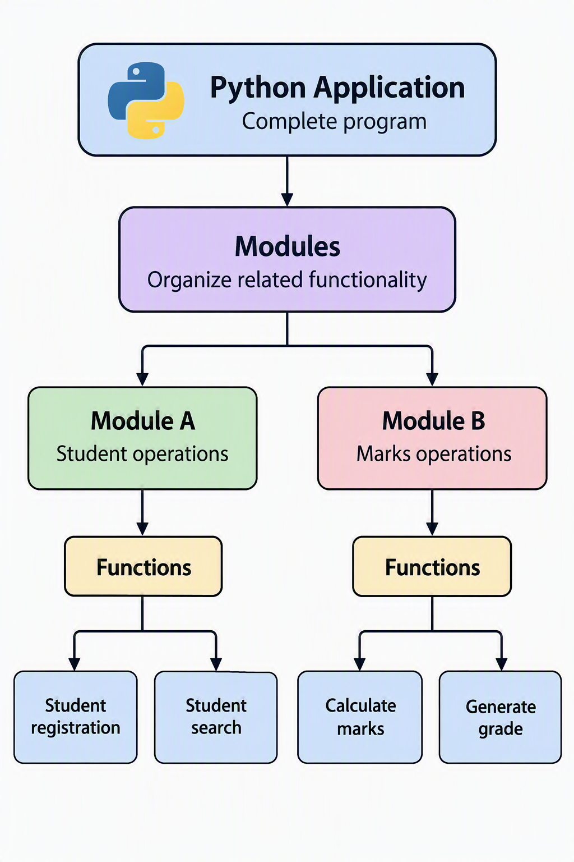
Hands-on Labs
▸ Calculator using functions
▸ Random password generator

